1. In “default” profile
   1. Reading Pet by Id

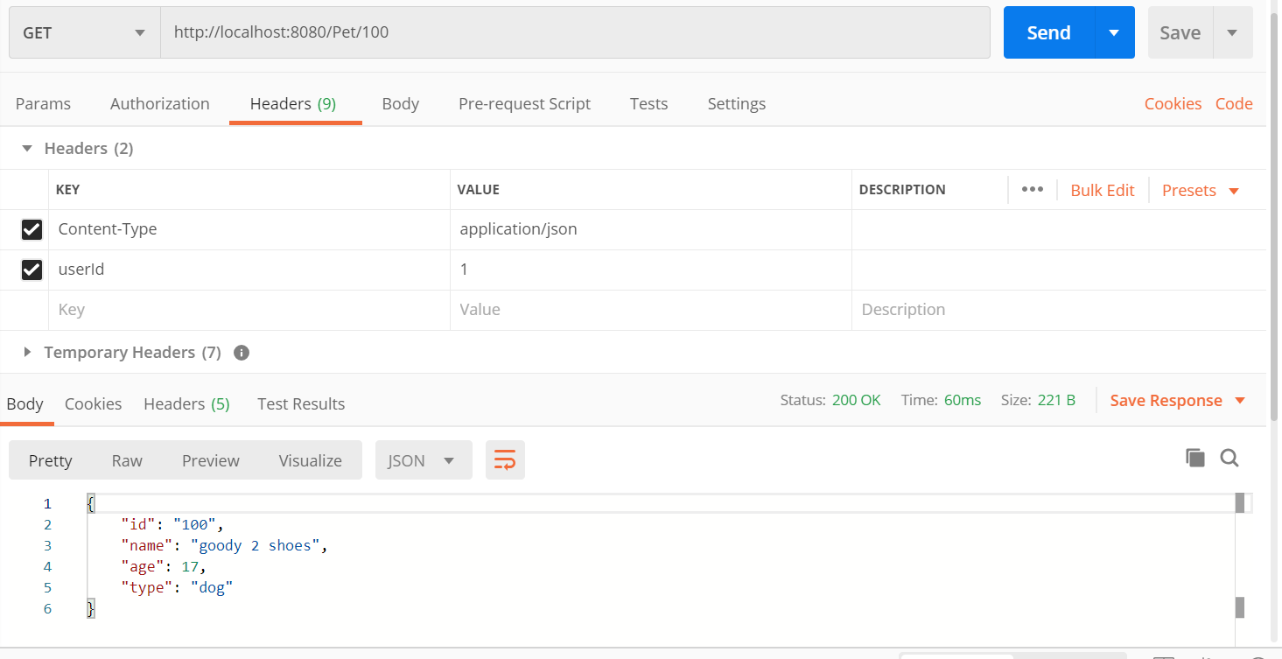

* 1. Read all pets
     1. In postman

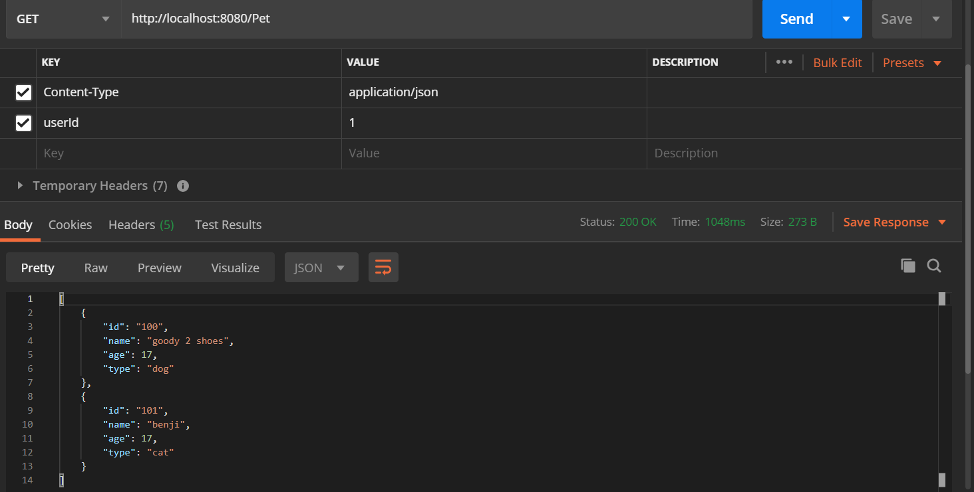

* + 1. In logs



* 1. Create pet
     1. In postman

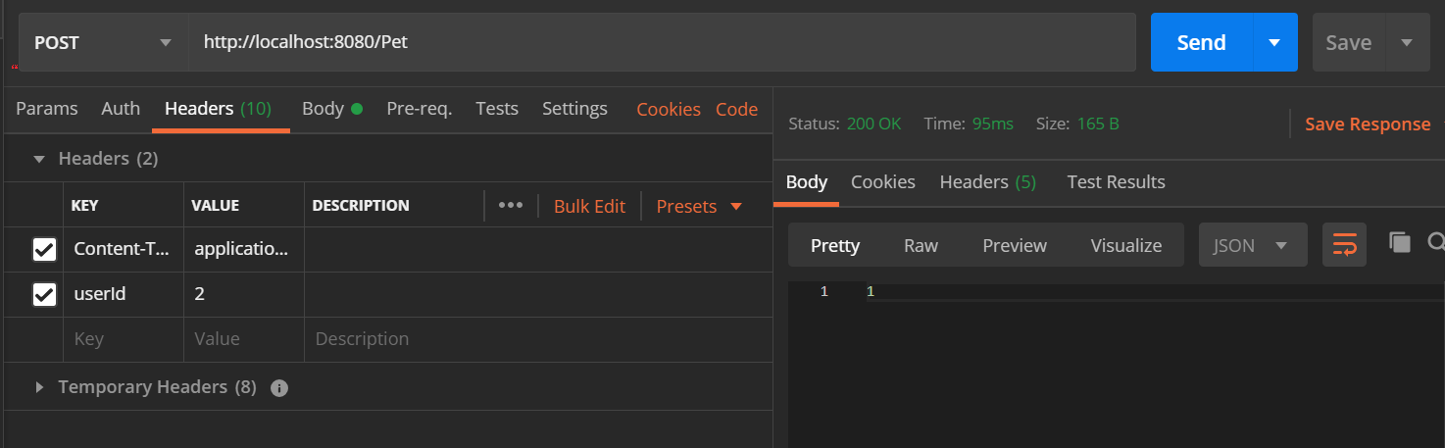

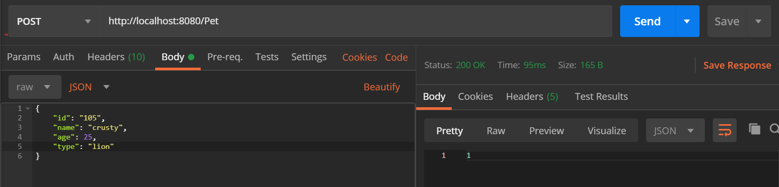

* + 1. In logs



* 1. Read by name and age
     1. In postman

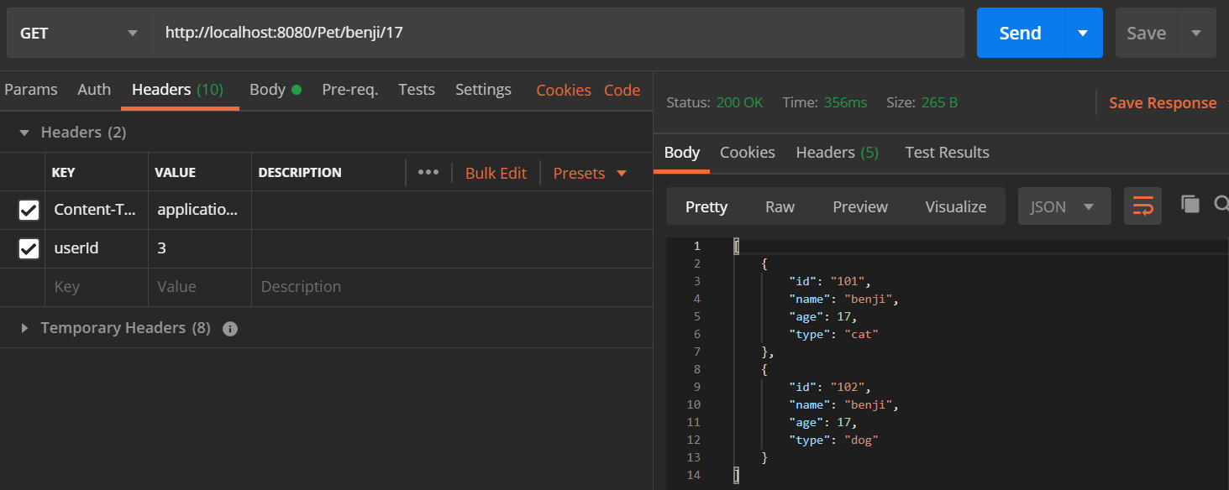

* + 1. In logs

 *in console

 *in log file

* 1. Update pet
     1. In postman

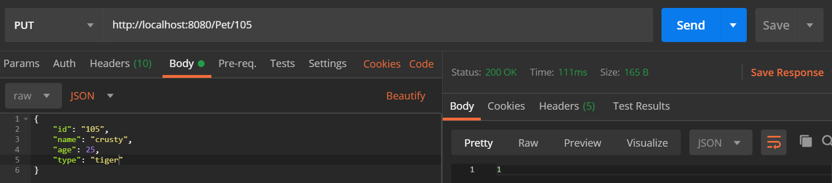

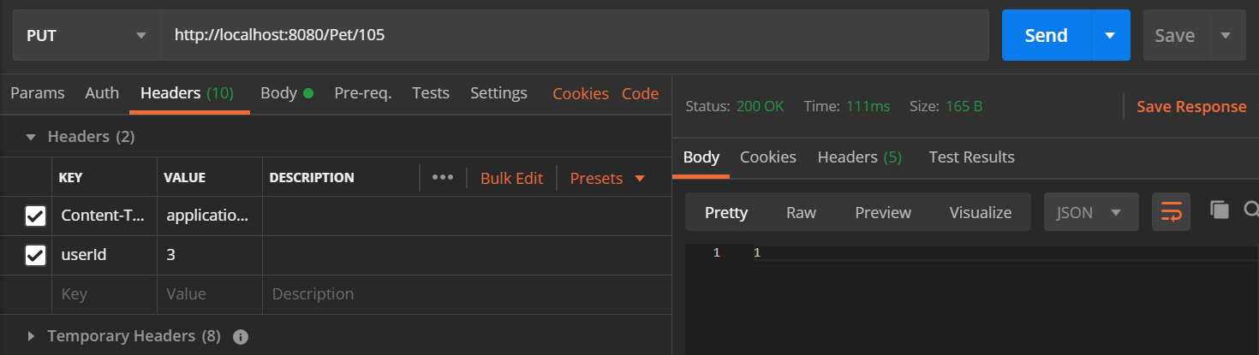

* + 1. In logs



* 1. Delete pet
     1. In postman

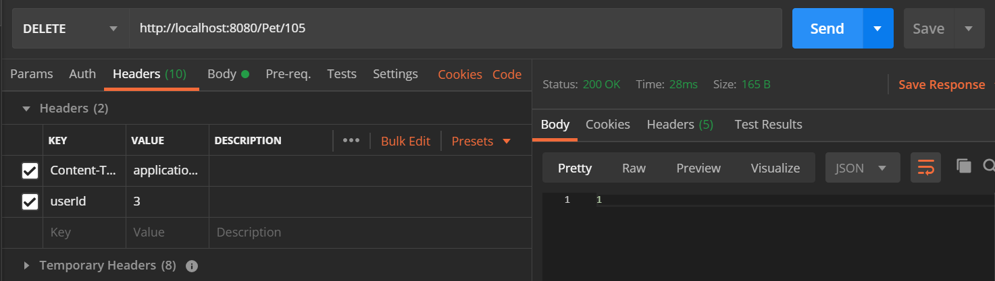

* + 1. In logs



1. In “prod” profile

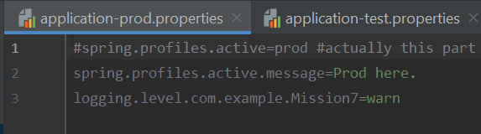

Since the logging level specified in “prod” is **warn**, those that are below that level will not be shown.

*Level is as follows

1. Error

2. Warn

3. Info

4. Debug

5. Trace

In my application, the only CRUD function(s) that has the level of warn and above is only the function called ‘deletePet’, so only when the delete pet request is sent, there will be a log for that.

1. In “test” profile

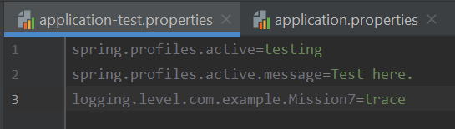

Since the logging level specified in “test” is **trace** – the lowest level, all levels of logging will be shown.

eg:

